

A PROJECT REPORT ON
Stories of Us

By
ALIZA SHAIKH

Towards The Partial Fulfillment of the
Bachelor of Computer Application

[TLFC-0217]
[Mumbai]

Tilak Maharashtra Vidyapeeth, Pune
Department of Computer Science [2025-2026]



CERTIFICATE

This is to certify that the project
“Stories of Us”
Has been satisfactorily completed by

Aliza Shaikh

Towards The Partial Fulfillment of the ‘Bachelor of Computer Application’,
For the Academic Year [2025-2026] at [TLFC-0217] Center, [Mumbai],
Tilak Maharashtra Vidyapeeth, Pune (Department of Computer Science), And it is approved.

Project Guide Examiner Head of Department
[TLFC – Mumbai]



ACKNOWLEDGEMENT

With immense pleasure we are presenting “StoriesOfUs Web Application” Project report as part of the curriculum of ‘Bachelor of Computer Application’. We wish to thank all the people who gave us unending support.

We express our profound thanks to our Head of Department Mr.“Vaibhav Diwadkar”, Project Guide Mrs.“Priyanka Sansare” and all those who have indirectly guided and helped us in preparation of this project.

ALIZA SHAIKH

Project Synopsis:

Name of the Project:

StoriesOfUs – Web Application

Front End:

- Android Studio
- Java

Back End:

- Fire base

Software Requirements:

- Android Studio
- Minimum Android Version 7.0

Hardware Requirements:

- Android Smartphone

Project Summary:
StoriesOfUs is an We Women Safety App that aims at empowering women by providing them with a comprehensive safety solution.As we navigate the digital landscape of safety, StoriesOfUs remains committed to its mission of ensuring the well-being and confidence of every user. It’s key features include Real-Time Tracking, Immediate Assistance through Emergency SOS Button, and Flexibility of SMS Alerts etc. It’s a Digital Guardian and a rapid response system that contributes to overall effectiveness and provides a highlighted security layer. This app would create an environment where women feel safe and confident in every setting.

ABSTRACT

In a landscape where personal safety stands as a paramount concern, our mission is to provide a reliable and empowering solution. Welcome to StoriesOfUs, a comprehensive platform designed to prioritize and enhance the safety of individuals in various circumstances.
Understanding the urgency for a steadfast remedy, we present a range of features aimed at ensuring not just security, but also peace of mind. From recognizing the necessity for a secure solution to comprehending the importance of a trustworthy environment, StoriesOfUs is your steadfast companion in navigating the complexities of personal safety, offering a seamless blend of technology and empowerment.
It is a comprehensive safety solution that incorporates a myriad of features, including emergency helpline numbers, actionable self-defense tips, a swift SOS panic button, discreet location sharing via SMS, and a repository of essential women's rights laws.
Furthermore, StoriesOfUs is dedicated to always evolving and adapting to the changing requirements and issues that women confront. We keep StoriesOfUs at the forefront of edge of personal safety innovation by providing continuous improvement and enhancements.
Whether it's integrating new features, improving existing functionalities, or extending our network of support services, StoriesOfUs is committed to staying ahead of the curve and giving women the skills they require to navigate the complexity of personal safety with confidence and resilience.

At its core, StoriesOfUs is a guardian, ever-equipped to accompany women on their journeys, whether or not it's a late-night time commute, a solo journey, or navigating unusual surroundings. With its user-friendly interface and intuitive functionalities, StoriesOfUs assures that assistance is only a tap away, empowering women to reclaim their experience of protection and autonomy.

INDEX

Sr.No | Topic | Page No.
1. | INTRODUCTION  - Concept Brief  - App Overview  - Goals  - Need  - Advantages  - Drawbacks | 12  TO  18
2. | OBJECTIVES  - Inclusivity and accessibility  - Empowerment through education  - Intersectionality with cultural sensitivity. | 19  TO 21
3. | INSIGHTS AND DATA VISUALIZATION  - State-wise Statistics  - Comprehensive Analysis of Women's Safety  - A Data-Driven Exploration of Safety, Policy, and Global  Perspectives  - Crime Against Women Under Indian Penal Code (IPC)  - Women's Safety Concerns: Reported Crimes Analysis | 22  TO  26

4. | TECHNOLOGICAL SPECIFICATIONS  - Software Requirement Specification  - A statement of the requirements for the implementation  - System Features  - Software Quality Attributes  - Overview Of Front End and Back End  - Android Overview  - Why Android  - Android Features  - Android Studio  - How Does it work?  - Java  - Advantages of Java  - Who Creates and Maintains Java?  - Java Version  - Firebase  - Advantages of Firebase  - Features of Firebase  - Limitations of Firebase  - Firebase Firestore Database  - Features of Firebase Firestore Database  - Advantages of Firebase Firestore Database  - Drawbacks of Firebase Firestore Database | 27  TO  46

5. | SOFTWARE DEVELOPMENT METHODOLOGIES  - Software Development Life Cycle (SDLC)  - SDLC Process  - Phase in the Software Development Life Cycle (SDLC)  - Waterfall Model  - Phases Of Waterfall Model | 47  TO  52
6. | SYSTEM DESIGN  - System Architecture  - Central Components  - Class Diagram  - UseCase Diagram  - Activity Diagram  - Sequence Diagram  - ER Diagram  - DFD Diagram- Level 0  - DFD Diagram- Level 1 | 53  TO  65
7. | MODULES | 66  TO 68
8. | GANTT CHART  - Gantt Chart Table  - Gantt Chart Graph | 69  TO 70
9. | APP PREVIEW  - Onboarding Screen  - Login Page | 71

 | - Verification Page  - Firebase Database  - HomePage  - Emergency Contact Page  - SMS Alert  - Location  - Helpline  - Self-defence  - Navigation Drawer  - Profile  - Settings | TO  83
10. | FUTURE SCOPE | 84  TO 85
11. | LIMITATION | 86  TO 87
12. | CONCLUSION | 88
13. | REFERENCES | 89  TO 90

LIST OF ABBREVIATIONS

SR NO. | ABBREVIATIONS | FULL FORMS
1. | NCRB | National Crime Records Bureau
2. | SOS | Save Our Souls
3. | SMS | Short Message Service
4. | SDLC | Software Development Life Cycle
5. | UML | Unified Modelling Language
6. | ERD | Entity Relationship Diagram
7. | SRS | Software Requirements Specification
8. | UTA | User Acceptance Testing
9. | DFD | Data Flow Diagram

10. | GPS | Global Positioning System
11. | IPC | Interprocess Communication
12. | JDK | Java Development Kit
13. | IBM | International Business Machines
15. | ML | Machine Learning
16. | FCM | Firebase Cloud Messaging

INTRODUCTION

CONCEPT BRIEF:

Women’s safety is a major concern in today’s fast-paced world. We have read about many tragic incidents that happen to women; the numbers are increasing. These days women are working women and globalization has made us realize gender equality. In the past, women were limited to household chores. With the changing landscape, women are competing with men in all fields. We can see women continuing to achieve greater success in all fields, be it corporate, scientific, academic, business, or any other field. Women’s safety in the home, outside the home, or in the workplace is critical. The last few crimes against women, especially in Delhi, have been very serious and horrific. Such crimes have made the safety of women a major issue.

Statistics show that two out of three women have suffered trauma last year. According to women's research, such statements indicate that women lose their self-confidence. According to NCRB data, crimes against women in Delhi account for 31.20% of the total crimes in this category. These statistics serve as a miserable call to action, encouraging society to prioritize women’s safety and well-being and create spaces where they can live free of fear and discrimination.

Women are harassed not only at night or in the evening but also during the day in their homes, offices, or other places such as parks, clubs, etc. The study shows that safety problems are caused by unfriendly environments in gender and inappropriate activity patterns such as no alcohol and drugs in open spaces, inadequate lighting, safe public toilets, footpaths, lack of effective policing, helplines lack of effective numbers, etc. A large percentage of women do not believe that the police can solve such problems. There is an urgent need to understand and address the problem of women's safety.

APP OVERVIEW:

In the face of growing security challenges, the StoriesOfUs- Women's Safety App stands as a beacon of hope, providing not only technological solutions but also a comprehensive approach to women's empowerment. In addition to a range of features designed to enhance physical security, StoriesOfUs fosters a sense of solidarity and support among its users. With StoriesOfUs, every woman has the power to reclaim her choice and put her own words out into the world. That’s why our app is your steadfast companion in navigating the modern world with confidence and peace of mind.

StoriesOfUs Women's Safety App is equipped with a comprehensive array of features designed to empower women and enhance their protection in various conditions. At the forefront is the SOS button, a vital lifeline accessible on the contact of a button. In instances of distress, users can activate the SOS characteristic to immediately alert predefined emergency contacts, sending out their particular place for rapid assistance. Furthermore, StoriesOfUs presents helpful defense hints, presenting sensible recommendations and techniques for self-safety in one-of-a-kind scenarios. From assertiveness techniques to self-defense, customers advantage of the understanding and self-belief to navigate hard conditions with tact.

Moreover, StoriesOfUs enables seamless location sharing through SMS, allowing customers to discreetly ship their whereabouts to depend-upon contacts in real time. Whether taking walks on our own or someone is in an unusual location, this selection provides an brought layer of security and peace of mind. Additionally, StoriesOfUs includes critical information on women's rights and relevant laws, empowering customers with an understanding of their prison protections and avenues for recourse in case of harassment or abuse.

Lastly, StoriesOfUs streamlines conversations with emergency contacts, permitting users to without problems control and replace their listing of relied-on folks who can be notified in times of need. By fostering a network of aid and sources, StoriesOfUs Women's Safety App equips women with the equipment they need to navigate the sector adequately and expectantly, making sure that they can assert their rights and reclaim their feeling of agency.

Target Audience:

The StoriesOfUs Women Safety App is designed for women of all ages and backgrounds who seek to enhance their safety and well-being. It caters to women living in urban, suburban, and rural areas, as well as those navigating both physical and digital spaces.

Mission:

By giving women the instruments, resources, and support they require to go through life with self-assurance, endurance, and agency, the StoriesOfUs Women Safety App seeks to empower them, improve their safety, and advance gender equality.

Vision:

The vision of the StoriesOfUs Women Safety App is to establish a society in which all women may live without fear of abuse, discrimination, or violence and in which their opinions are acknowledged, valued, and respected. The app aims to empower women by using technology, education, and actions to stand up for their rights, defend themselves, and effect constructive social change.

GOALS:

A sense of empowerment of women and strengthening their safety in all facets of life are the main goals of the StoriesOfUs Women Safety App. The app seeks to address the particular problems encountered by women by offering complete assistance, resources, and solutions through a multidimensional approach.

Safety Enhancement:

Offering women a sense of security and empowerment in their daily tasks is the primary focus of the safety enhancement function in the StoriesOfUs Women Safety App. The app attempts to create a setting where women feel safer and more secure navigating their surroundings, whether they are at home, work, or in public settings, by providing a suite of useful tools and information. Offering features like real-time location sharing, emergency contact notifications, and self-defense guides and resources at their fingertips.

Resource Accessibility:

Given that women's safety can be significantly impacted by their ability to receive timely help, the app is made to offer easy access to a multitude of information and services at the push of a button. The app guarantees that women, irrespective of their location or circumstances, have instant access to the support they want, ranging from emergency numbers and helplines to crisis intervention centers and legal aid groups.

Education and Awareness:

Through the provision of profound educational resources and data on women's rights, safety recommendations, and legal protections, the app equips women to confidently and assertively handle a variety of scenarios. Users may access materials that provide information about their legal rights, useful safety recommendations for various situations. It also makes sure that women are aware of how to get in contact with emergency shelters, counselling services, helplines, and legal aid. The app's ultimate goal is to educate and empower women so they can take charge of their own safety and wellbeing and express their agency.

NEED:

The continual obstacles and dangers to women's safety and wellbeing in society are what made the StoriesOfUs Women Safety App necessary. Women still confront grave risks and obstacles to safety in their daily lives, even in the midst of continuous attempts to combat gender-based violence and discrimination. The app is a vital resource for meeting this demand since it gives women access to critical safety information, support networks, and tools for empowerment. It provides women with a lifeline to express their agency, protect themselves, and navigate their lives with confidence and security in a society where women frequently feel vulnerable and excluded especially in public settings and online.

- Preventing Gender-Based Violence
- Confidence and empowerment
- Fast Access to Assistance

Preventing gender-based violence:

Women are disproportionately affected by domestic abuse, sexual assault, and other forms of violence. Women can defend themselves with the skills and resources provided by the Safety App, and they have access to assistance when they need it.

Confidence and empowerment:

Having access to safety apps can give women a sense of control over their safety. Their confidence to handle potentially hazardous circumstances can increase when they are aware that resources and assistance are easily accessible.

Fast Access to Assistance:

Time is of the essence during an emergency. Features like emergency notifications and emergency response are common in women's safety applications, enabling users to call for assistance quickly. at circumstances where they may be at danger of losing their life.

ADVANTAGES:

Help Alert: : Help alert is a crucial feature in women's safety apps. When a user feels threatened or in an emergency, they can immediately send out alerts or distress signals. This feature usually consists of an easily accessible SOS button or assigned emergency contact that users may press to alert authorities, emergency services, or trusted connections about their predicament. In order to provide a prompt response, help notifications frequently contain the user's location information.

Shifting Social Norms: By promoting gender equality, increasing awareness of gender-based violence, and challenging cultural attitudes and behaviors that support violence and discrimination against women, women's safety applications can help change social norms.
These apps frequently include chances for community involvement, advocacy tools, and educational materials to support users in advocating for change and helping to build a more secure and just society for all.

Location sharing and real-time tracking: Location sharing and real-time tracking are essential features of women’s safety apps that allow users to share their location with trusted contacts or emergency offices and track their movements in real time. This feature can be particularly useful in an emergency, allowing responders to quickly locate and assist users. It can also give users a new sense of security, knowing that their site is being monitored and that they can call for help if necessary.

Enhanced Safety: The tools, resources, and features that women's safety apps offer to their users to assist them defend themselves and lessen their susceptibility to violence or harm are collectively referred to as enhanced safety. These could include risk assessment instruments, safety advice, self-defense methods, and connections to emergency shelters, counselling services, and helplines. Women's safety applications work to improve users' safety and well-being in a variety of scenarios by providing them with information, skills, and support.

DRAWBACKS:

Privacy Concerns:

In order to offer their full range of capabilities, which include real-time tracking and emergency notifications, women's safety applications frequently need access to personal information, including contact lists and location data. On the other hand, this presents legitimate privacy issues about the gathering, storing, and possible abuse of private user information. Users might be reluctant to divulge such information out of concern about privacy violations, harassment, or other types of maltreatment. Furthermore, there might not be as many oversight and accountability systems in places with weak data protection laws, making it harder to guarantee that user data is handled safely and morally.

Risk of False Alarms:

Most women's safety applications come with emergency alert functions that let users contact assistance right away if they're in danger. Nevertheless, there's a chance of unintentional or false activations, which could tax emergency response capabilities and damage the app's reputation. User error, technical issues, or mistaking non-threatening circumstances for crises can all result in false alarms. To mitigate this risk, users must be given detailed guidance on when and how to use emergency features responsibly in addition to the implementation of strong verification methods.

Limited Technical Reach:

In order to provide the services, women's safety applications depend on technology, namely cell phones and internet access. However, the app's impact can be limited in areas with low smartphone penetration rates or limited access to technology. Women from underprivileged homes or marginalized areas may also encounter difficulties obtaining or buying cell phones, which further restricts their capacity to take advantage of women's safety apps.

OBJECTIVE

The intent of the our Women's Safety App is to empower women with a reliable and accessible tool that will improve their safety and security in a variety of situations. Through a comprehensive range of features and services, the app aims to address the challenges faced by women in today's society. It acts as a digital partner, offering support, resources and support to women whenever they feel vulnerable or threatened.

One of the main goals of the app is to provide emergency services, such as contacting law enforcement or a trusted contact in a tragic situation. It includes features such as location tracking, which allows users to share their real-time location and contacts, ensuring that they can be located quickly in the event of an emergency subtle distress signals or panic buttons for send alerts silently, without alerting potential threat users.
In addition, the app gives women a sense of community and unity by sharing safety tips, information on safe roads, and warnings about potential dangers in specific areas. It also includes educational materials on self-defense strategies and legal rights, enabling women to gain the knowledge and skills to actively defend themselves.

The role of sound women safety solutions will be like a digital companion and a guardian for them to push their limits wherever they want. Now, with the security app solution at their disposal, girls no longer have to answer a few questions from well-wishers or their families, such as “Where are they?”, they can now be free from worry. Women’s safety solutions can provide any solution a woman needs at any critical time without any hassle.

The purpose of our women's safety app, StoriesOfUs, encapsulates three fundamental principles:
- Inclusivity and accessibility
- Empowerment through education
- Intersectionality with cultural sensitivity.

Inclusivity and accessibility:

- The objective is to make the app accessible to women from all walks of life, regardless of socioeconomic status, ethnicity or geography. Therefore the intent is that women even in remote areas might have the accessibility and thus they too can have a digital guardian with them wherever they go.

- This will make women independent and give them the power and self-confidence to move and carry out their daily tasks without any hassle and this accessibility will help them to develop necessary technical skills that are required.

- By making use of flexible design and language options to accommodate users with a variety of technical skills. Making a user-friendly interface and encouraging inclusion and equal access to protective gear for all women.

Empowerment through education:

- Providing comprehensive resources on defense mechanisms, legal rights, and potential threat identification and management will help women to know about their rights and be aware about the various circumstances that might arise and how they need to face each situation.

- Empowering women is a way to enhance their confidence in all walks of life, and also be aware about their rights and their power to make a change in the various fields they are in. Women can ensure their personal safety and make it their utmost priority.

- Equipped knowledge and skills that will enable women to confidently address a range of security challenges. Encouraging a culture of empowerment by encouraging continuous learning and skill development. By educating each women there will be a sense of security among them to strieve and know their power to secure themselves and other women around them.

Intersectionality with cultural sensitivity:

- Acknowledging the parallel experiences of women and the unique challenges faced by women from different cultures. Modifying the app's features to meet the specific needs and concerns of different user groups. Promoting a supportive and inclusive environment that respects and fosters cultural diversity while effectively addressing safety concerns.
- This involves conducting thorough research and engaging with diverse communities to understand their unique safety challenges, preferences, and cultural sensitivities. By incorporating customizable features, language options, and culturally relevant resources, the app can better cater to the diverse needs of its users. For example, providing safety tips tailored to specific cultural contexts.

Overall, the app strives to provide a safe and inclusive world where women can move freely, knowing that they have a trusted companion in their pocket, ready to help them whenever they needed it most.

INSIGHTS AND DATA VISUALIZATION

State-wise Statistics

In India, violence against women continues to be a widespread and deeply ingrained problem that has a variety of social, psychological, and physical aspects. Gender-based violence episodes continue to occur despite legislative measures and cultural initiatives. These incidents can take many different forms, including domestic abuse, sexual assault, harassment, violence tied to dowries, and human trafficking. These crimes perpetuate a culture of fear and insecurity among women by causing not just acute bodily pain but also long-lasting psychological wounds. Safety concerns loom large, especially in public spaces where women often face harassment and intimidation, hindering their freedom of movement and participation in social and economic activities. Addressing these safety concerns demands a multi-faceted approach, encompassing robust legal frameworks, enhanced law enforcement measures, community engagement, education, and empowerment initiatives. A society where women may live fearlessly, with dignity and respect, and with equal opportunity for everyone becomes essential as we face the ugly reality of gender-based violence in India.

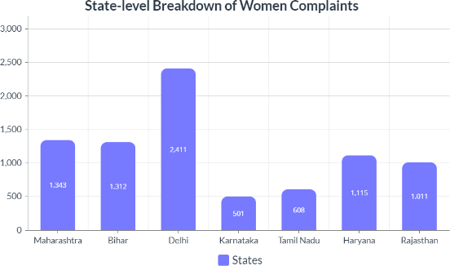

Figure 3.1: State-level Women Complaints Statistics

Comprehensive Analysis of Women's Safety: Insights, Statistics, and Data Visualization"

Crime Rates and Trends :

India's crime statistics and patterns paint a complicated and alarming picture, especially when it comes to issues that impact women's safety. Attack, harassment, domestic abuse, and stalking occurrences continue despite attempts to reduce gender-based violence. Regional differences in frequency and changes in crime rates over time are shown by statistical analysis. Underreporting, which hides the actual scope of the issue, is still a major obstacle.

Safety Perception Surveys :

In India, studies on safety perception are essential for comprehending women's experiences and worries about safety in different contexts. These studies capture the many situations in which women traverse their everyday lives, including public locations, workplaces, educational institutions, and home regions. Such surveys provide valuable insights into how secure or vulnerable women feel in various settings, pointing out areas that need further investigation and support. Women's feelings of safety are influenced by several factors, including illumination, infrastructure, law enforcement presence, and social attitudes towards gender-based violence.

Gender-based Violence Statistics:

India's gender-based violence statistics present a horrifying image of widespread and systemic abuse against women. The rate of sexual assault, femicide, and intimate partner violence is still frighteningly high despite government initiatives and community efforts. Underreporting, which is caused by things like social shame and fear of harm, is one of the big problems. In order to address gender-based violence in India and build safer and more equal settings for all people, it is necessary to implement comprehensive legislative frameworks, policy initiatives, and a radical change in cultural attitudes and gender norms.

A Data-Driven Exploration of Safety, Policy, and Global Perspectives

Legal and Policy Analysis:

The legal and policy landscape surrounding women's safety is complex and constantly evolving. Some key areas of focus include:
- Strengthening legislation
- Improved law enforcement practices
- Community-based initiatives

Social Media and Online Harassment:

The explosion of social media has created a double-edged sword for women's safety. Platforms provide chances for connection and self-expression, but they also create new pathways for online harassment and abuse. Women are disproportionately subjected to hostile comments, threats, and stalking. This can have a severe detrimental influence on their mental health, limiting their online activity. To make the online environment safer for women, social media businesses must develop tougher policies against online harassment, invest in improved content filtering, and provide users with reporting mechanisms.

International Comparisons:

When it comes to women's safety, international comparisons provide insight into best practices and opportunities for growth. Countries with high rankings frequently put emphasis on factors such as:
- Social Safety Nets
- Gender equality.
- Invest in preventative measures.
- Strong legislative frameworks

Crime Against Women Under Indian Penal Code (IPC)

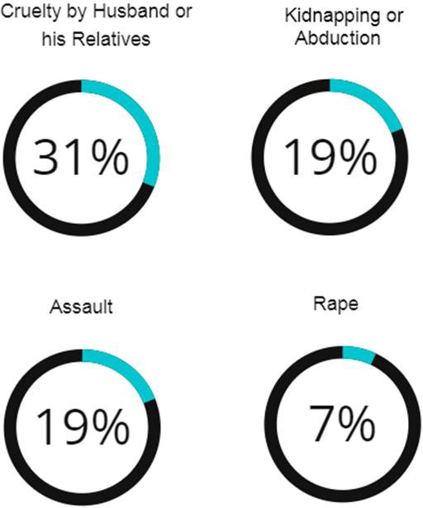

Figure 3.2: Women's Crime Rates: Indian Penal Code (IPC) Offenses

It sheds light on the widespread horrific crimes against women under the Indian Penal Code (IPC) .The most common offenses included cases of 'cruelty by the husband or his relatives', accounting for 31.4% of the reported cases, highlighting women's permanent vulnerability in the family setting and then 'kidnapping and abduction of women', figures for 19.2% of the cases, 'Assault on Women with Outrage Her Modesty' stands as another notable concern, representing 18.7% of reported incidents occur highlighting the ongoing challenges of preventing sexual harassment and violence against women.
The report highlights the severity of 'rape', accounting for 7.1% of cases. These statistics need resources a complete immediately to prevent gender-based violence, ensure access to justice and promote that society emphasizes where women can live free from fear and exploitation.

Women's Safety Concerns: Reported Crimes Analysis

According to the report, a considerable majority of crimes against women under the Indian Penal Code (IPC) involve 'Cruelty by Husband or His Relatives' (31.4%), 'Kidnapping and Abduction of Women' (19.2%), 'Assault on Women with Intent to Outrage her Modesty' (18.7%), and 'Rape' (7.1%). The crime rate per lakh women population increased to 66.4 in 2022 from 64.5 in 2021.

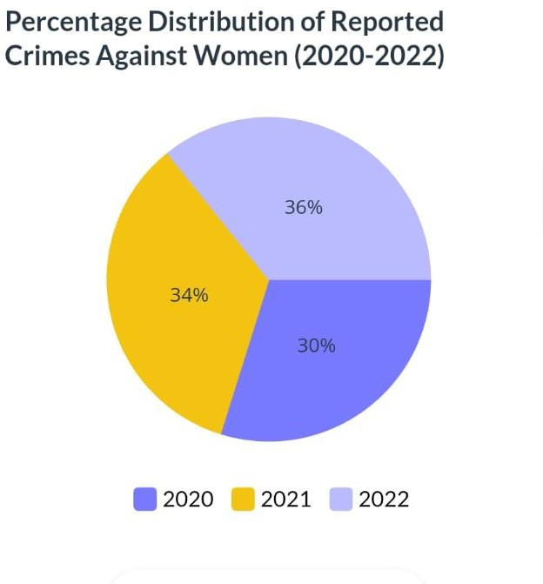

Figure 3.3: Crimes reported against women 2020-2022

TECHNOLOGICAL SPECIFICATIONS

Software Requirement Specification:

The Software Requirements Specification (SRS) serves as the cornerstone for your Web Application's development journey using Android Studio. This crucial document, meticulously crafted during the analysis phase, defines the application's functionalities, performance expectations, and target audience. A well-defined SRS starts with a clear vision, outlining the application's purpose, its intended users (both technically savvy and those new to technology), and the specific problems it aims to solve. Data handling becomes a key consideration, detailing the type of data the application will work with, its storage needs local or remote on servers, and how this data flows throughout the application.

Functionality takes centre stage as user stories and use cases are defined. User stories paint a picture of how users will interact with the application to achieve specific goals, while use cases goes deeper into concrete scenarios showcasing these interactions. Functional requirements become the building blocks, meticulously listing all the functionalities the application must provide. These requirements detail inputs, outputs, and the expected behaviour of each feature. However, defining what the application does is just one piece of the puzzle. The SRS also establishes validation criteria, essentially the success metrics foreach functionality. In order know if a particular feature is working as intended, this is where acceptance criteria and testing strategies come into play.

Acceptance criteria define the benchmarks for each feature, while the testing strategy outlines a comprehensive plan for evaluating the application's performance. Unit testing ensures individual components function correctly, integration testing verifies how these components work together seamlessly, and user acceptance testing (UAT) brings the user's perspective to the table, ensuring the application delivers a positive user experience.

But when it comes to Android development, the SRS takes on an additional layer of complexity. Specifying the minimum and target Android versions the application will support becomes crucial. After all, you want your application to reach as many users as possible while maintaining functionality. Similarly, any specific hardware or software requirements, like camera access or sensor support, need to be clearly defined. The user interface (UI) also plays a vital role. The SRS should outline the application's visual style, whether it adheres to Android's Material Design principles for a familiar and consistent user experience, or if it adopts a custom design approach.

The importance of a clear and concise Software Requirement Specification cannot be overstated. By meticulously defining these aspects and fostering open communication with stakeholders, developers, designers, and clients, you can significantly reduce misunderstandings later in the development process. A well-defined Software Requirement Specification translates into improved project management, allowing for better planning, estimation, and resource allocation. Furthermore, clear requirements serve as a guidepost for developing a comprehensive testing strategy, ensuring the application functions as intended and delivers a valuable experience for your users. Remember, the Software Requirement Specification is a living document, and as the project progresses and user feedback is incorporated, the Software Requirement Specification may need to be revisited and updated to reflect these valuable insights.

A statement of the requirements for the implementation:

Specifications are additionally used as a reference point for product implementation. In fact, the ultimate purpose of implementation is to create a product that requires specifications.
Thus, implementers use specifications during design to make design decisions and during verification to ensure that the implementation corresponds with the specifications.

System Features:

- Emergency Contacts:

These are people or groups you have designated as the first people to call in an emergency. These could be neighbors, friends, relatives, or emergency services like the fire department, police, or ambulance. Keeping a list of emergency contacts close at hand will help guarantee that the right action is taken as soon as necessary and speed up the process of seeking aid when needed.

Location Tracking:

Many female safety apps offer real-time GPS tracking, allowing designated contacts or authorities to locate the user in an emergency. This feature can be especially useful for individuals traveling alone or in unfamiliar environments.

Secure routes and Location Sharing:

Some apps allow you to coordinate and share safe routes with trusted contacts. Users can share their real-time location with friends or family members as they travel, allowing them to track their progress and take immediate action if needed.

Safety tips and resources:

Women’s safety apps often provide educational materials on personal safety, self-defense techniques, and information about local support services and helplines. These resources provide users with users can acquire the knowledge and tools to protect themselves and seek help when needed.

Software Quality Attributes:

Software quality attributes are measurable or testable characteristics that indicate how well a software system meets the needs of its users.
Software quality qualities pose major concerns during the development and testing stages of software development. These characteristics go beyond the software's fundamental functionality and include features that affect user experience, system performance, maintainability, and overall effectiveness. By focusing on these quality attributes, developers may ensure that their software is not only functional, but also dependable, safe, useable, and customised to the specific demands of its users.

Security:

A Women's Safety App relies heavily on security measures. Without strong security measures, the app's primary function of protecting users in vulnerable situations is compromised. Sensitive user data, such as names, phone numbers, emergency contact information, and even medical information requires the highest security. Encryption at rest and in transit protects this information from unauthorized access, even in the case of a database breach. Strong password hashing techniques are critical for preventing brute-force attacks on user credentials.
Access controls with multi-factor authentication provide an additional layer of protection, guaranteeing that only authorized users have access to the app and its features. It is ensured that these vulnerabilities are fixed before they may be exploited by promptly delivering security updates. Throughout the development process, using secure coding methods reduces the possibility of creating vulnerabilities in the first place. Maintaining security is a continuous effort that requires steadfast attention.

Usability:

The building block of an effective women's safety app is usability. An app that is quick to open, easy to use, and intuitive is what a user needs in an emergency. It might be quite harmful to struggle with a complicated interface or confusing functionalities. This is how giving usability top priority empowers users:
The interface should have few words, easily recognizable icons, and be tidy and uncluttered.

It should be easy to reach large, prominent buttons, such as the SOS button, that may be used to initiate alarms with little effort.
Even in stressful situations, locating important elements like resource lists, emergency contacts, and incident reporting should be simple. Quick access to the app's features is ensured via simple and logical navigation.
Ultimately, a user-friendly Women's Safety App becomes an extension of a user's safety net, providing comfort and confidence in potentially life-threatening situations.

Reliability:

The foundation of dependability in a women's safety app is reliability. The software application must always work well when a user who is in danger uses it for assistance. Downtime at a crucial delay could have disastrous effects. Encouraging reliability gives users the following benefits:

Smooth operation is ensured by routine maintenance and performance monitoring. Precise user data, location data, and emergency contact information are key. Data integrity is maintained via strong error handling and validation procedures. When a user initiates an alert, each second matters. Notifications should be sent out quickly and alerts should be processed quickly by the app. Achieving quick reaction times requires optimizing server performance and communication connections. Users can depend on the app's reliability and they can gain a crucial sense of security and confidence in its ability to protect them.

Availability:

"Availability" as a software quality attribute in the context of a women's safety app refers to the dependability and accessibility of the application's services whenever they are needed. It guarantees that the application is always functional and responsive to user demands, particularly in urgent circumstances.

Availability is important for women's safety apps because it guarantees uninterrupted access to emergency services like location sharing, SOS alerts, and contact notifications. This characteristic includes things like feature responsiveness, network dependability, and server uptime.

Accuracy:

Accuracy pertains to the accurate and consistent operation of its functions, particularly location tracking, emergency detection, and alerting methods. Accurate location monitoring guarantees that the application can locate the user's exact location, allowing for immediate aid from emergency personnel. The software must accurately identify true emergency situations, reducing false alarms while quickly identifying legitimate dangers. Furthermore, reliable alerting methods ensure that emergency notifications are delivered to selected contacts or authorities as soon as possible, delivering critical information for prompt and effective response.
Overall, accuracy is critical to ensuring that the women's safety app achieves its primary goal of increasing users' safety and security, maintaining accuracy is essential for smooth functioning of the application and enhancing safety.

Maintainability :

A women's safety app's maintainability, as a software quality attribute, is how easily it can be updated, changed, and maintained over time. It covers a wide range of topics, including modular design, readability of the code, high-quality documentation, and the capacity to make modifications without unforeseen impacts.

Maintainability is essential for a women's safety app to be able to adjust to changing user needs, technology improvements, and security specifications. It enables developers to quickly and effectively add new features, correct errors, and fix vulnerabilities.
Maintainability ensures the long-term viability and effectiveness of a women's safety app by enabling it to evolve and remain relevant in an ever-changing environment.

Overview Of Front End and Back End: -

- Front End:- Android Studio, Java.
- Back End:- Firebase.
- Database System:- Firebase Firestore Database.

Android Overview: -

Android reigns supreme in the mobile world, holding the title of the best-selling operating system for smartphones and tablets.
This open-source, Linux-based platform powers billions of devices globally.

Developed by a consortium led by Google, Android offers a unified approach to app development, allowing developers to code once and deploy their creations across a vast range of Android devices.
This focus on compatibility makes it an attractive choice for developers.

Beyond app development, Android boasts a user-friendly interface, customizable features, and access to the ever-growing Google Play Store, brimming with apps, games, and other digital content.
This combination of developer-friendly tools, user customizability, and a rich app ecosystem has solidified Android's position as the dominant force in the mobile landscape.

Why Android?
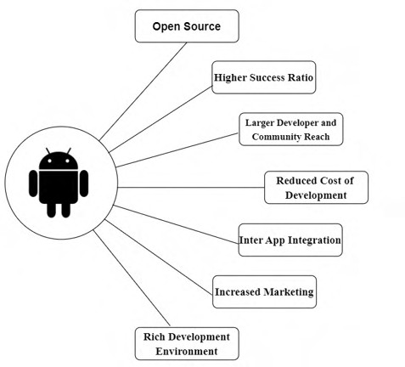
Figure 4: Benefits Android

Android Featues:

Beautiful UI
Android OS basic screen provides a beautiful and intuitive user interface.

Storage
SQLite, a lightweight relational database, is used for data storage purposes.

Web browser
Based on the open-source WebKit layout engine, coupled with Chrome's V8 JavaScript engine supporting HTML5 and CSS3.

Multi-touch
Android has native support for multi-touch which was initially made available in handsets such as the HTC Hero.

Multi-tasking
User can jump from one task to another and same time various application can run simultaneously.

Android Studio:

      - Android Studio is a specialized IDE tailored for creating Web Applications.

      - Android Studio is built on top of JetBrains' IntelliJ IDEA software, which provides a robust and feature-rich development environment.

      - It provides a powerful code editor with features like syntax highlighting, code completion, and refactoring tools to enhance productivity.

      - Android Studio includes a visual layout editor that allows developers to design app interfaces visually using drag-and-drop components.

      - It comes bundled with an Android emulator that enables developers to test their apps on virtual Android devices with different configurations.

      - Android Studio offers a comprehensive set of tools for designing, building, and testing Web Applications.

How Does it work?

Android Studio is a powerful tool for creating Android apps. It's like a one-stop shop, where you can do everything from writing code (with helpful features like syntax highlighting and debugging tools) to designing the user interface (using drag-and-drop tools and a live preview). It even manages the app's resources and integrates with building and testing systems. This allows you to code the app's logic, build its visual appearance, and test it on virtual devices or your own phone - all within a single environment. For more advanced users, Android Studio offers even more features, like performance optimization tools, cloud integration options, and access to a vast library of pre-built functionalities. In short, Android Studio empowers you to develop your mobile app from start to finish.

Java:

Java is a powerhouse programming language widely used for building a variety of applications. Imagine it as a versatile tool for crafting software – from the web applications you use daily to the mobile apps on your phone.
Java boasts several key features: it's object-oriented, meaning it organizes code using real-world concepts; it's designed to be portable, allowing code to run on different computer systems; and it prioritizes security, making it a trusted choice for developers.
This combination of features makes Java a popular language for building everything from enterprise software and big data applications to mobile games and even the software behind many websites.

Advantages of Java:

Write Once, Run Anywhere (WORA): Java code is compiled into a bytecode format that can run on any platform with a Java Virtual Machine (JVM). This eliminates the need to rewrite code for different operating systems.

Object-Oriented: Java is an object-oriented programming language, allowing developers to create modular and reusable code components, promoting cleaner and more maintainable applications.

Secure: Java enforces strong memory management and type checking, reducing the risk of security vulnerabilities compared to languages with manual memory management.

Large and Active Community: Java boasts a vast and supportive community of developers, providing ample resources, libraries, and forums for learning and troubleshooting.

Simple and Easy to Learn: Java has a relatively easy-to-understand syntax, making it a good starting point for new programmers.

Rich Ecosystem of Libraries and Frameworks: Java benefits from a wide range of readily available libraries and frameworks that offer pre-built functionalities for various tasks, accelerating development.

Mature and Stable: With over two decades of development, Java is a mature and stable language, ensuring reliable performance for enterprise applications.

Multithreaded: Java supports multithreading, enabling applications to handle multiple tasks simultaneously, improving responsiveness and performance.

Who Creates and Maintains Java?

Java's creation story involves a joint effort. Sun Microsystems initially developed Java in the 1990s, but after their acquisition by Oracle in 2010, Oracle now owns the official Java trademark. However, the language's development isn't a one-man show.
The OpenJDK community, a group including Oracle, IBM, and many other developers, collaboratively contributes to Java's evolution.
So, while Oracle has the final say on the official Java platform, the vibrant OpenJDK community plays a crucial role in shaping Java's future.

Java Version:

The world of Java isn't static - new versions are released periodically. These updates introduce new features, improve performance, and often address security concerns.
Think of them as upgrades to your favourite software, constantly enhancing Java's capabilities.
There are two main branches: Long Term Support (LTS) versions offering extended support for critical applications, and non-LTS versions that introduce cutting-edge features for those willing to adopt the latest advancements.

Long Term Support (LTS) Versions:

- Prioritize stability and extended support (several years).
- Ideal for critical applications requiring reliability.
- Imagine them as dependable workhorses.

Non-LTS Versions:

  - Focus on cutting-edge features and functionalities.
  - Cater to developers seeking the latest advancements.
  - Think of them as high-performance race cars.
  - Typically have shorter support lifespans.

Firebase:-

Firebase isn't just a single tool, it's a developer's toolbox for building web and mobile apps. Imagine it as a suite of services offered by Google, all designed to streamline the development process and enhance your app's functionality. Firebase offers various features like databases for storing user data, user authentication to manage logins, and hosting services to store your app's code and content. It even throws in some bonus features like built-in analytics to understand user behavior and machine learning tools to add cool functionalities like image recognition. By providing pre-built solutions for common tasks, Firebase empowers developers to focus on what matters most: creating engaging and innovative apps.

Advantages of Firebase:

Streamlined Development: Firebase offers pre-built solutions for common tasks like databases, authentication, and hosting, allowing developers to focus on creating unique app features and functionalities rather than building everything from scratch.

Simplified User Authentication: Firebase removes the complexity of managing user logins and signups. With built-in features, users can sign in using their email, password, or social media accounts, eliminating the need for developers to code complex authentication systems from scratch.

Scalable Cloud Databases: Firebase provides flexible and scalable databases that grow alongside your app's user base. You can choose from various options like Realtime Database for real-time data synchronization or Cloud Firestore for structured data storage.

Actionable App Analytics: Firebase Analytics empowers you to understand how users interact with your app. You can track user engagement, identify areas for improvement, and measure the effectiveness of your marketing campaigns.

Effortless Cloud Functions: Firebase Cloud Functions let you write server-side code that executes in response to events triggered within your app. This eliminates the need to manage your own servers for functionalities like sending notifications or processing data..

Features of Firebase: -

- Firebase Features: A Developer's Toolkit for Building Powerful Apps
- Firebase by Google empowers developers with a comprehensive suite of tools and services to streamline mobile and web app development. Here's a breakdown of some of its key features:

Databases:

  - Realtime Database: Stores and synchronizes data across devices in real-time, ideal for collaborative apps or live updates.
  - Cloud Firestore: Offers a flexible document-oriented database for structured data storage, perfect for managing user profiles or game progress.

Authentication:

  - Email/Password: Enables user login with email addresses and passwords, providing a secure and familiar login method.
  - Social Sign-In: Simplifies user registration by allowing logins through popular social media accounts like Google or Facebook.

Hosting:

  - Static Hosting: Hosts static web app content like HTML, CSS, and JavaScript files, ensuring fast and reliable delivery.
  - Cloud Storage: Provides a secure and scalable platform for storing and managing other app assets like images, videos, and audio files.

Cloud Functions:

  - Serverless Backend: Allows developers to write server-side code that executes in response to events triggered in the app, eliminating the need for managing separate servers.

  - Scalable Functionality: Handles tasks like sending notifications, processing data, or interacting with external services efficiently.

Analytics:

    - User Behaviour Tracking: Provides insights into user engagement, app usage patterns, and crash reports, allowing for data-driven app improvements.
    - Marketing Measurement: Helps measure the effectiveness of marketing campaigns by tracking user acquisition and conversion rates.

Machine Learning:

  - Firebase ML Kit: Integrates machine learning capabilities without extensive ML expertise. Developers can add features like image recognition, text recognition, or natural language processing to their apps.

Remote Configuration:

  - Dynamic App Configuration: Enables dynamic changes to app behavior and appearance without requiring a new app release.
  - A/B Testing: Allows for A/B testing of different app features to optimize user experience and identify the most effective design choices.

Cloud Messaging (FCM):

  - Reliable Messaging: Delivers push notifications to users' devices even when the app is in the background, keeping them informed and engaged.
  - Targeted Messaging: Enables sending targeted notifications based on user preferences or behaviour segmentation.

In-App Messaging:

  - Contextual Communication: Allows sending targeted messages directly within the app to guide users, promote features, or deliver personalized content.
  - Improved User Engagement: Enhances user onboarding experiences and drives user engagement within the app.

App Distribution:

  - Simplified App Delivery: Streamlines the process of distributing your app to various app stores like Google Play Store or Apple App Store.
  - Beta Testing Management: Manages beta testing programs for collecting user feedback before a public release.

Crashlytics:

  - Real-time Crash Reporting: Identifies and analyzes app crashes in real-time, allowing for swift bug fixes and improved app stability.
  - Performance Monitoring: Tracks app performance metrics to pinpoint areas for optimization and ensure a smooth user experience.

Limitations of Firebase:

Firebase Limitations: Mind the Roadblocks Before You Build

While Firebase offers a robust set of tools for mobile and web app development, it's not without limitations. Here are some key considerations to keep in mind:

Data Storage Limits: Firebase's databases, Realtime Database and Cloud Firestore, have limitations on the amount of data you can store and manipulate at once.

Security Considerations: While Firebase offers built-in security features, it's crucial to understand and implement them effectively.

Limited Offline Functionality: While some Firebase features like Cloud Firestore can be configured for offline functionality, it's not universally applicable across all functionalities.

Vendor Lock-In: By relying heavily on Firebase, you might become reliant on Google's cloud platform. While migrating away from Firebase entirely is possible, it can be a complex process.

​Firebase Firestore Database:

Firestore is a robust, scalable NoSQL database provided by Google Cloud as part of the Firebase platform. Firestore is designed for mobile, web, and server development, and saves data in flexible JSON-like documents organised into collections. Its main feature is real-time data synchronisation, which ensures that all connected clients receive instant updates.
Firestore's seamless scalability and offline capabilities enable developers to create responsive, collaborative applications. Flexible rules provide security, and interaction with Firebase services enhances utility. Overall, the Firestore stands out as a flexible and robust solution for modern app development, providing developers with the tools they need to create high-quality experiences across various platforms.

Features of Firebase Firestore Database:

Real-time updates:

Firestore provides real-time updates to connected clients, ensuring that changes made to the database are immediately reflected across all devices and platforms.

Offline access:

Firestore offers offline data access, allowing users to interact with your app even when they're offline. Changes made while offline are synced with the server once the device is back online.

Integration with Firebase Services:

Firestore seamlessly integrates with other Firebase services such as Authentication, Cloud Functions, and Cloud Storage, enabling developers to build feature-rich applications with minimal effort.

Security:

In Firestore Database, security rules can be defined to control who can access your data and what actions they can perform. These rules are enforced server-side, ensuring data integrity and security.

Multi-platform Support:

Firestore supports a wide range of platforms, including iOS, Android, web, and server environments, making it easy to build cross-platform applications with a shared backend.

Serverless:

Firestore is a serverless database, meaning you don't need to manage servers or infrastructure. Google handles all the backend infrastructure, including scaling, maintenance, and updates, allowing you to focus on building your application.

Advantages of Firebase Firestore Database:

Real-time Updates:
Firestore offers data syncing in real-time. Updates are sent very instantly to all connected clients as data changes, making it perfect for interactive applications..

Scalability:
Firestore is made to scale automatically, thus it can easily manage very big data sets and is appropriate for expanding applications that don't require manual scaling.

Automated Backups:
Firestore provides options for automated backups, guaranteeing that data is consistently preserved and ready for restoration in case of need. This automated procedure improves the dependability of data protection measures while reducing the burden on developers and IT personnel.

Automatic Indexing:
Firestore automatically indexes data to optimize query performance, reducing the need for manual index management and ensuring efficient data retrieval, even for complex queries.

Security Rules:
Firestore allows you to define fine-grained security rules to control access to your data. These rules are enforced server-side, providing robust security for your application's data.This protects critical information, such as user locations or emergency contacts, from unauthorized access or alteration, enhancing user privacy and safety.

Global Scalability and Reliability:

Firestore offers global data replication and strong consistency guarantees, ensuring low-latency access to data from anywhere in the world. This makes it suitable for building globally distributed applications with high availability and reliability.

Drawbacks of Firebase Firestore Database:

Query Limitations: While Firestore supports powerful querying capabilities, there are some limitations compared to traditional SQL databases. Complex queries, joins, and aggregations may be more challenging to implement, and some types of queries may not be supported.

Costs: Firestore operates on a pricing model based on the number of reads, writes, and data storage, which can become expensive for high-traffic applications or large datasets.
Developers need to carefully monitor usage and plan for potential costs as their application scales.

Data Structure Limitations: Firestore's NoSQL data model, while flexible, may not be suitable for all types of data or application requirements. Developers need to carefully design their data model to avoid performance issues or data duplication.

Data Privacy and Compliance: Storing sensitive or regulated data in Firestore may raise concerns about data privacy and compliance with industry regulations such as GDPR or HIPAA. Developers need to implement appropriate security measures and compliance controls to ensure data protection and regulatory compliance.

Limited Offline Support: Firestore provides built-in support for offline data access, but there are limitations to this feature. Offline support is only available on certain platforms and for certain data operations. Additionally, conflicts may arise when multiple clients modify the same data while offline.

Vendor lock-in: Firestore is a proprietary service offered by Google Cloud, which means that migrating away from Firestore to another database platform may be challenging.
Developers should consider the long-term implications of vendor lock-in when choosing Firestore for their applications.

Software Development Methodologies

Software Development Life Cycle (SDLC):

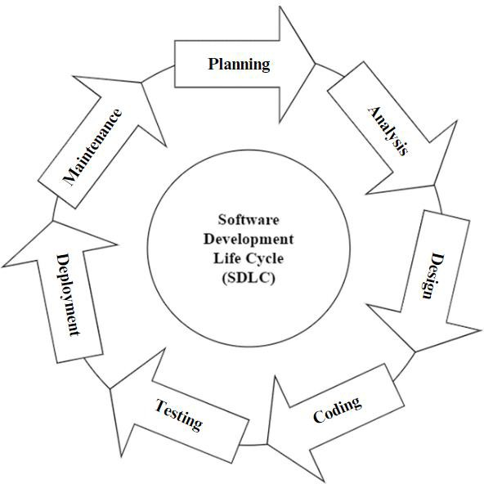

Figure 5.1 : SDLC Life Cycle

The Software Development Life Cycle (SDLC) provides a structured approach to developing software. It encompasses numerous significant stages, from planning and understanding needs, to releasing and maintaining the software. SDLC provides a systematic approach for guiding development. It ensures projects are done efficiently and effectively. The typical SDLC phases include gathering requirements, design, building the software, testing, deployment, and maintenance. These facilitate progress of the project from conception to completion while meeting quality standards and expectations. By following SDLC, organizations can reduce risks, control costs, and deliver highquality software solutions.

SDLC Process:

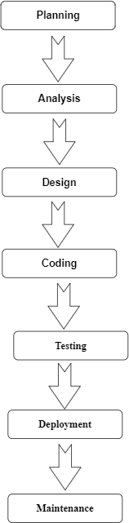

Figure 5.2 : SDLC Process

  - Phase in the Software Development Life Cycle (SDLC):

Planning:

During this phase, people involved in the project determine the project's scope, objectives, and requirements. The planning process includes gathering user needs, conducting feasibility studies, and developing a project strategy. Project charters, requirements documents, and initial project schedules are among the key deliverables.Planning phase is crucial in understanding the needs and requirements of the user.

Analysis:

During the analysis phase, the project team thoroughly examines the requirements acquired during the planning stage. This includes determining user demands, specifying system functionalities, and defining system requirements. This phase produces a thorough requirement specification document.Analysis is important in undersatnding what has been planned and to implement it accordingly.

Design:

In the design phase, the system architecture and software design are created using the requirements acquired during the analysis phase. This comprises developing the overall system structure, database architecture, user interface, and software components. System architecture diagrams are among the key deliverables.

Coding :

The implementation step involves creating codes and developing software based on the designs created during the preceding phase. Developers write code, integrate software components, and do unit testing to ensure that individual modules work properly. This phase produces a workable software product that is suitable for testing.

Testing: A crucial stage of the Software Development Life Cycle (SDLC) is testing, during which the program is thoroughly examined to confirm its functionality, dependability, and performance. There are a number of additional factors to take into account throughout the testing process in addition to the testing jobs that have been stated, such as unit testing, integration testing, system testing, and user acceptability testing (UAT).

Deployment: In the Software Development Life Cycle (SDLC), deployment is a crucial stage where software moves from development to live production. Deployment requires meticulous planning and coordination in addition to the technical requirements of configuration and installation to guarantee a seamless transition. This entails carrying out readiness evaluations to confirm that the hardware resources and network connectivity in the production environment are adequate to support the new software.

Maintenance: The Maintenance phase starts after deployment. It entails continuing to support and maintain the software to guarantee its security, functionality, and conformity to changing business requirements. Fixing bugs, dealing with software flaws or problems, improving or adding new features, performance tracking, and optimization to increase system scalability and efficiency are all included in maintenance operations.

Waterfall Model:
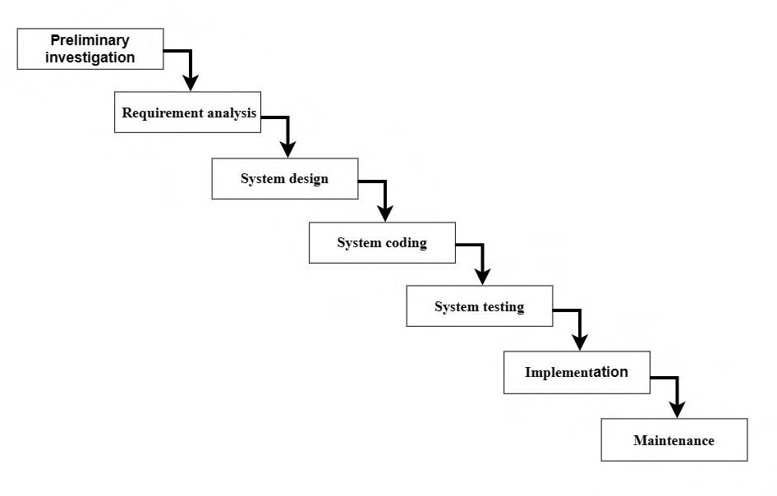

Figure 5.3 : Waterfall Model

In the waterfall model, the process is organized as a cascade of stages, where production one phase plugs into the next phase. Each section is also organized as a set of tasks that may be performed by different people at the same time. as an example of a waterfall specify a sequential linear flow between stages, each stage must provide an output standard of practice. If the outcome of a stage is poor, it can affect subsequent stages.

Waterfall models are also useful for measuring the progress of a project.

Each stage of the waterfall model represents a specific activity, with progression from stage to stage.At its core, the waterfall model organizes the development process into a series of steps, which typically include requirements gathering, design, implementation, testing, implementation, and maintenance Importantly, . each step must be completed before moving on to the next, with no room for repetition or review once the platform is complete.

Phases Of Waterfall Model:

- Preliminary investigations: - Preliminary investigations are carried out to find the root cause the problem for which the system should be designed.

- Requirements Analysis: -System and software requirements are listed and review with client.

- System Design: - Once the requirements are understood, the design phase begins. This requires a detailed policy document that outlines software configuration, user, and system components.

- System coding: - In this stage the logical aspects of the design are changed Machine reading method. The main focus of this step is logical content.

- System testing; - This step in the waterfall model is to detect and check for faults Defined inputs that can produce expected results.

- Implementation: The implementation phase involves actual coding or programming based on system design. Developers write code according to specifications specified in design documents. This phase focuses on building a software program with coding standards, best practices, and any relevant guidelines.

- Maintenance: - Maintenance step of waterfall model takes care by implementing all types of maintenance of the system such as
  - Corrective maintenance for removal of residual errors.

  - Adaptive maintenance for hardware.

  - Perfective maintenance to enhance the quality of the software.

SYSTEM DESIGN

System Architecture

The diagram depicts the various components and interactions within a women's safety app system, emphasizing features that prioritize user safety and reliable communication in emergency situations.

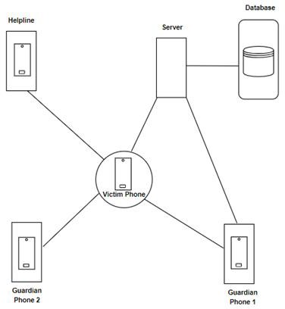

Figure 6.1: System Architecture

  - Central Components:

Mobile App (Smartphone):

This is the user interface where victims interact with the app. Key features include a prominent SOS button for triggering alerts, silent guardian mode for discreet alerts, location sharing with emergency contacts, incident reporting with audio/video recording capabilities, and access to a list of emergency resources.

Data Processing and Storage:

Application Server (Cloud):

This central server processes incoming alerts from the mobile app. It verifies user identity, retrieves emergency contact details, and triggers notifications based on user preferences (silent or audible alerts). The server sends SMS or text messages to emergency contacts with the user's location and a help message. Additionally, it may integrate with emergency services APIs for a faster response from police or ambulance services. The server also stores anonymized usage data (e.g., location data with timestamps, types of alerts sent) which can be used for analysis and optimizing resource allocation.

Database (Cloud):

This secure storage system holds user data. Key data points include user ID and authentication credentials, emergency contact information (names, phone numbers, relationships), and user preferences (notification settings, silent guardian mode). Optionally, the database can store medical information if the user chooses to share it. Additionally, anonymized usage data collected from the app is stored for analysis purposes.

Class Diagram

A class diagram is a structural diagram used in computer science to show a system's static structure by depicting the classes, properties, methods, and relationships between classes. It visually depicts the structure of objects in an object-oriented system, demonstrating how they are organised, interrelated, and interact with one another. Class diagrams are a fundamental tool for creating, documenting, and understanding the architecture of software systems, facilitating stakeholder communication and directing the implementation of object-oriented programming paradigms.

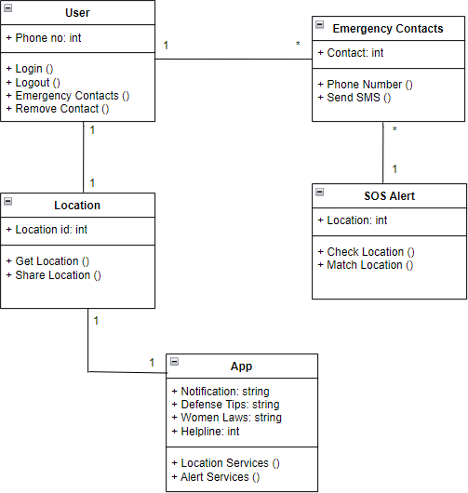

Figure 6.2: Class Diagram

  - UseCase Diagram

A use case diagram is a form of behavioural diagram in Unified Modelling Language (UML) that depicts how actors (users or external systems) interact with the system under consideration to achieve certain goals or activities. It gives a high-level view of the system's functions through the eyes of its users, concentrating on the actions they do and the system's responses to those activities.

Use case diagrams are made up of actors, use cases, and their relationships, such as affiliations, generalisations, and includes/extends interactions. They are an effective method for recording and visualising a system's functional requirements, assisting with requirements analysis, stakeholder communication, and system functionality validation.
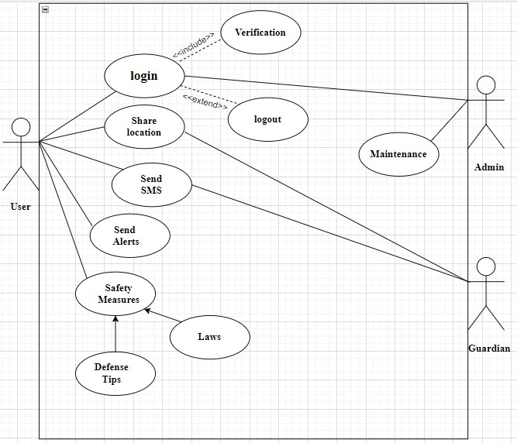

Figure 6.3: UseCase Diagram

  - Activity Diagram

In Unified Modeling Language (UML), an activity diagram is a kind of behavioral diagram that shows how actions and activities move through a system or process. It offers a visual depiction of the sequential and concurrent actions taken by objects or actors within the system in order to finish a task or reach a certain objective. Activity diagrams show the steps, decision points, concurrency, and order of steps using a variety of symbols, including activities, joins, transitions, and decisions. They are frequently used to model system behavior, define business processes, and spot possible bottlenecks or workflow inefficiencies throughout the analysis and design stages of software development.
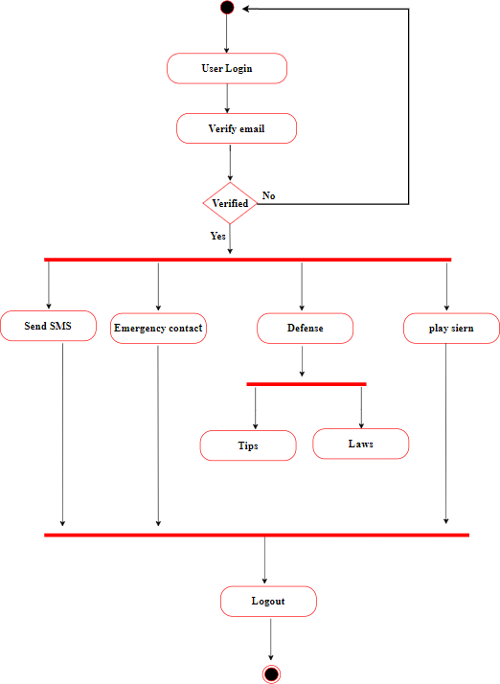

Figure 6.4: Activity Diagram

  - Sequence Diagram

In UML, a sequence diagram shows how objects or components interact with one another inside a system. It displays the sequence in which these objects have exchanged messages over time. A vertical lifeline represents each object, and messages are shown as arrows connecting lifelines. Sequence diagrams aid in the understanding of data and control flow within a system by developers. When modeling dynamic behavior and communication patterns in software systems, they are especially helpful. Sequence diagrams can depict method calls, answers, and concurrent activities, as well as basic and complicated interactions between objects. The design, analysis, and documenting of software systems are facilitated by these diagrams.

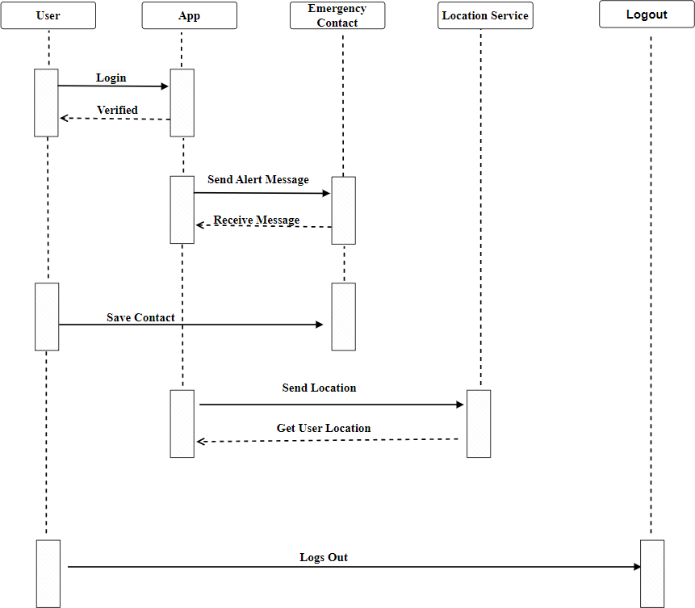

Figure 6.5: Sequence Diagram

  - ER Diagram

The relationships between entities in a database are shown visually in entity-relationship (ER) diagrams. It provides an example of a database's structure by demonstrating the relationships between various entities. Relationships between entities are shown as lines connecting them, and entities themselves are represented as rectangles. The attributes of each entity are listed within the rectangle that represents the entity and describe its properties. Relationships between entities can be:
- One-to-One,
- One-to-Many,
- Many-to-Many.

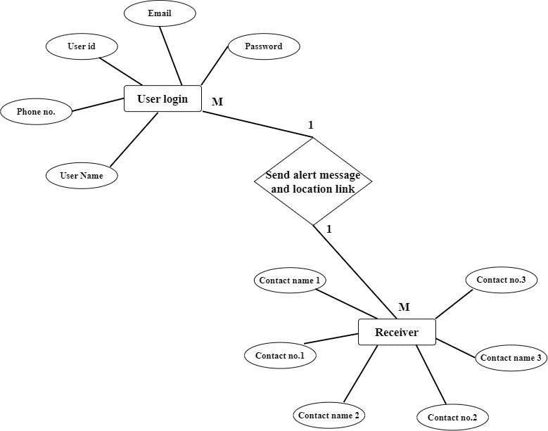

Figure 6.6: ER Diagram

An Overview of Entity-Relationship (ER) Diagram:

- Users: The system stores user information through User entities. It includes attributes like username, email address, phone number, and potentially an emergency contact.
- Login: The login process verifies a user's credentials username and password to grant access to the app's functionalities.
- Contacts: The app allows users to store emergency contact information.
The Contact entity likely stores details like contact name and phone number. There's a many-to-many relationship between Users and Contacts, indicating a user can have multiple contacts, and a contact can be linked to multiple users (i.e., be an emergency contact for multiple people).
- Sending an Alert: The core function of the app seems to be sending an alert message and location to emergency contacts. When a user initiates an alert, the system retrieves the user's information and retrieves contact details linked to the user's emergency contact .

The ER diagram represents a simplified model of a women's safety app that focuses on user login, contact storage, and the emergency alert functionality.

User Login and Sending an Alert:

- This is a one-to-many relationship.
- One User: This represents a single user of the app who logs in with their credentials username and password.
- Many Alerts: This user can send multiple alerts in case of emergencies.

Alert and Receiver Relationship:

  - Another is one-to-many relationship.
  - One Alert: This represents a single alert message sent by a user.
  - Many Receivers: This alert message can be sent to multiple emergency contacts chosen by the user.

DFD Diagram- Level 0

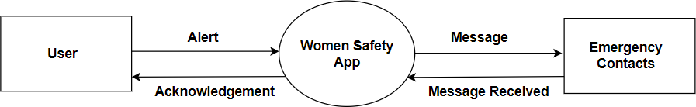

Figure 6.7: Zero Level Data Flow Diagram

Central Process: Women's Safety App

- This is the heart of the system, represented by the large circle in the center. It encapsulates all the functionalities and processes happening within the Women's Safety App.
- Internally, the app might have various sub-processes for handling different tasks, like:

  - Managing user accounts and authentication.
  - Processing alerts and triggers based on user actions (SOS button, silent guardian mode, incident reporting).
  - Accessing and displaying emergency resources (helplines, police stations, shelters).
  - Utilizing GPS data to determine user location for emergency purposes.
  - Sending notifications and alerts to emergency contacts via SMS, text messages, or other communication channels.
  - Optionally, integrating with emergency services APIs for faster response.

External Entities:

- User: This represents the individuals who have downloaded and registered with the Women's Safety App.

  - Users interact with the app through its interface, initiating various actions like:
  - Triggering alerts (SOS button, silent guardian mode).
  - Reporting incidents with details and potentially audio/video recordings.
  - Viewing emergency resources and safety information.
  - Managing emergency contact information.

- Emergency Contacts: These are the people designated by the user to receive notifications or requests for help in case of an emergency. They can be:

  - Family members.
  - Close friends.
  - Emergency service providers (police, ambulance) - depending on the app's capabilities and local regulations.

Data Flows:

- Alerts (User to App): This arrow depicts the flow of data from the user to the app. It represents user actions that trigger an emergency response or request for help:

  - Pressing the SOS button.
  - Activating silent guardian mode.
  - Reporting an incident with details like text, audio, or video recording.
  - Choosing to share their location with emergency contacts.

- Information (App to User): This arrow shows the app providing information back to the user. This could include:

  - Confirmation of a received alert and ongoing processing.
  - Estimated arrival time of help (if integrated with emergency services).
  - Displaying relevant safety tips based on the user's situation.
  - Presenting a list of nearby emergency resources based on the user's location.
  - Updates on the status of their sent alert or incident report.

- Information (App to Emergency Contacts): This arrow represents the app sending information to the user's designated emergency contacts in case of an alert. The data flow might include:

  - User's current location information for quicker assistance.
  - A pre-programmed message requesting help or indicating danger.
  - Additional details from the user's incident report (if applicable).

DFD Diagram- Level 1

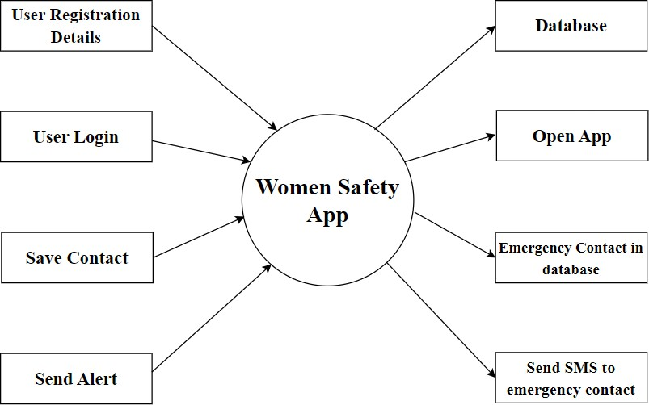

Figure 6.8: First Level Data Flow Diagram

A Data Flow Diagram (DFD) Level 1, builds on the high-level picture provided by a Context Diagram (DFD Level 0. It focuses on decomposing the single process in the Context Diagram into its major sub-processes. This level goes deeper into the system, revealing the functional components that collaborate to achieve the primary objective.

Within a Level 1 DFD, processes are represented by circles, data flows by arrows, and data stores by rectangles. The processes describe the system's basic operations, whereas data flows show how information is exchanged between these processes and other entities. Data stores serve as repository for information used by all processes in the system.

User Registration:

The process begins with user registration. During registration, the user enters their details which are stored in a database.

User Login:

Once registered, the user can log in to the app with the details The app verifies these credentials against the stored user information in a database which will lead to successful login in the app.

Save Contact:

The user can save emergency contact information within the app. These contacts would be people the user wants to be notified in case of an emergency. This information is stored alongside the user's details in the database.

Send Alert:

If the user feels unsafe, they can send an alert through the app. The users can use the SOS Button, Send SMS to Emergency Contacts, and notify them with their current location.

Send SMS to Emergency Contact:

Upon receiving an alert, the app automatically sends an SMS to the user's emergency contacts, presumably notifying them of the user's situation and potentially including the user's location.

MODULES

Emergency Contacts:

  - Adding and Managing Contacts:

Users can add phone numbers, email addresses, and even relationships (mom, dad, best friend) for each contact.

Quick Dial:

With a tap or swipe, users can directly initiate a call, text message, or even share their location with an emergency contact.

SOS Alert:

  - Action Trigger:

This can is a dedicated button, a shake gesture, or a combination that is used to initiate an alert.

Alert Content:

- Pre-written message with user's location sent to emergency contacts.
- Option to customize the message for specific situations.

Emergency Call:

Connecting directly to pre-programmed emergency services or a designated helpline.

Silent Mode:

Option to send a silent notification to contacts without alerting the user's surroundings (flashing light or vibration).

- Real-time Location Tracking:

  - Sharing Options:

Allow users to share their location:

Privacy Settings: Users can tailor their sharing preferences based on specific contacts or groups, allowing them to control who can view their real-time location . This feature provides flexibility and ensures privacy while still enabling users to share their whereabouts with trusted individuals when needed.

a. Upon activating the SOS alert:

In case of an emergency, this is the best solution.
The program notifies emergency contacts of the user's current location when they press the SOS button.

This is an efficient method of sharing location during an unexpected incident without having to track all the time.

Self-Defense Resources:

  - Content Library:

It includes articles, or interactive tutorials on basic self-defense techniques.

Situational Awareness Tips:

Provide guidance on how to identify and avoid potentially risky situations an be aware about all that it happening around.

Emergency Response Plans:

The app can offer advice on what to do during different types of emergencies which would help the users to get immediate assistance and also be aware about the surroundings and also educate others regarding the same.It will help the users to react quickly and swiftly in times of need.

Emergency Services Directory:

  - Local Emergency Hotlines:

The app should includes contact information for police, women helpline, emergency numbers , and other relevant important helplines that will ensure that users have access to emergency phone numbers for their immediate assistance.

GANTT CHART

  - ​Gantt Chart Table:

Development Task | Start Date | End Date | Duration
Application Blueprinting | 07-02-2024 | 14-02-2024 | 8 Days
Resource Accumulation | 15-02-2024 | 19-02-2024 | 5 Days
Application Design | 20-02-2024 | 05-03-2024 | 15 Days
Testing | 06-03-2024 | 10-03-2024 | 5 Days
Coding | 11-03-2024 | 13-03-2024 | 34 Days
Final Testing | 14-04-2024 | 20-04-2024 | 7 Days

Figure 8.1: Gantt Chart Table

  - Gantt Chart Graph:

This horizontal bar chart displays the development timetable for a women's safety app. Each bar represents a development stage, such as Application Design , Testing, etc and its length indicates its duration. The x-axis depicts task durations, while the y-axis shows the tasks themselves. This graphic depicts a rapid visual summary of the project timeline.

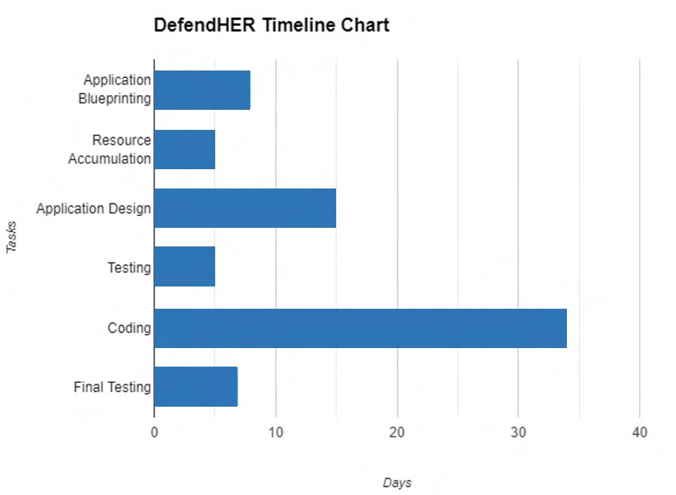

Figure 8.2: Gantt Chart Timeline Graph

APP PREVIEW

Onboarding Screen:

Welcome To Women Safety App:

These images represent Onboarding Screen of the application

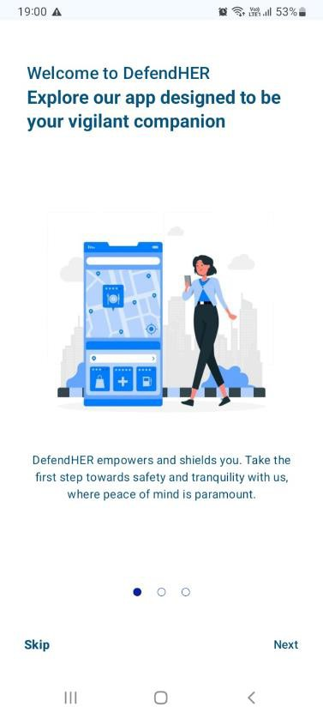
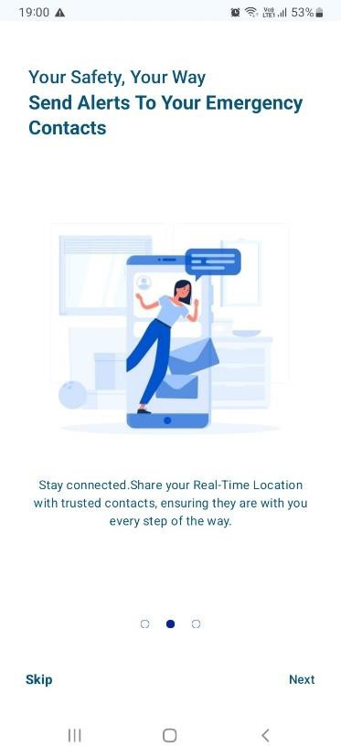
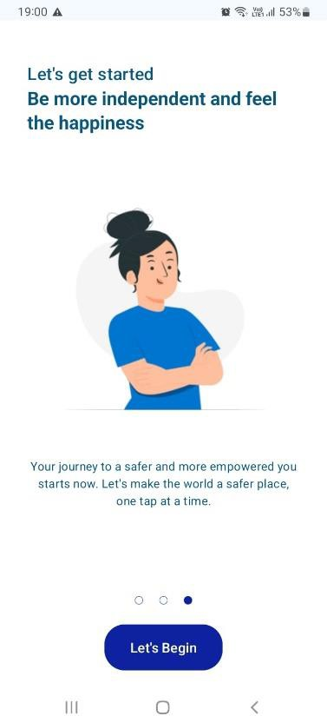

Figure 9.1: Onboarding Screenshot

- Login Page:

Sign Up allows users to create an account so that they can access the features and functionality of the app.
Users first need to register with their details and verify themselves.

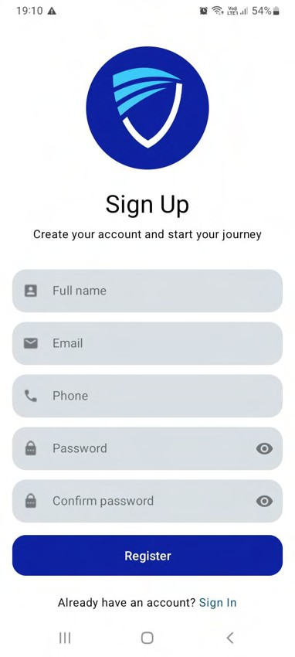
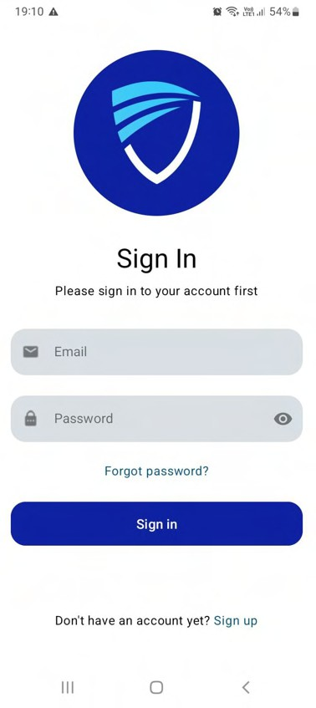

Figure 9.2: Login page

- Verification Page:

A message informs the user that an email has been sent to the mail address. Instructions are provided to click on a link in the email to complete the signup process. In case the user cannot find the email, they are advised to check their spam folder.

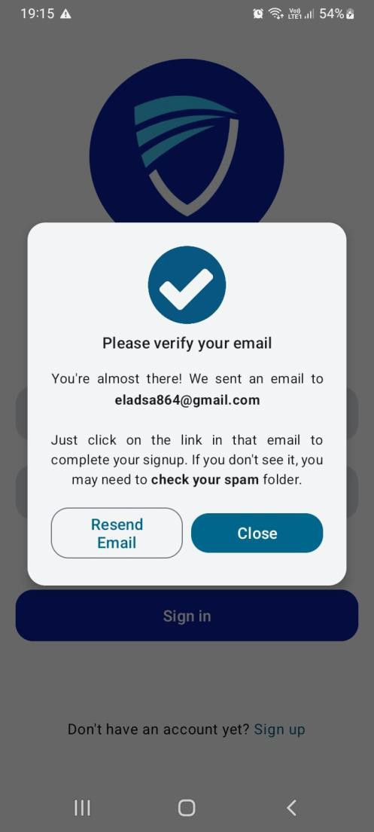
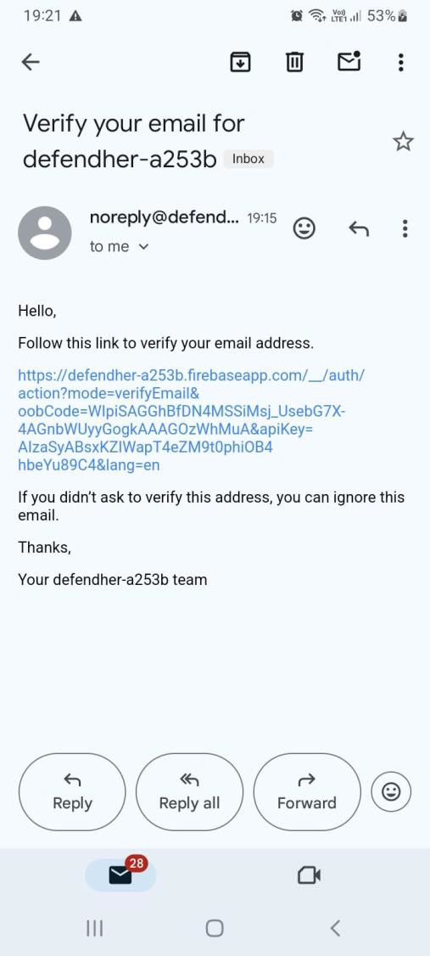

Figure 9.3:Verification page

- Firebase Database:

These images show Firebase project user authentication page. It shows a list of users with their email addresses, creation dates, last sign in dates, and unique identifiers along with the project dashboard.

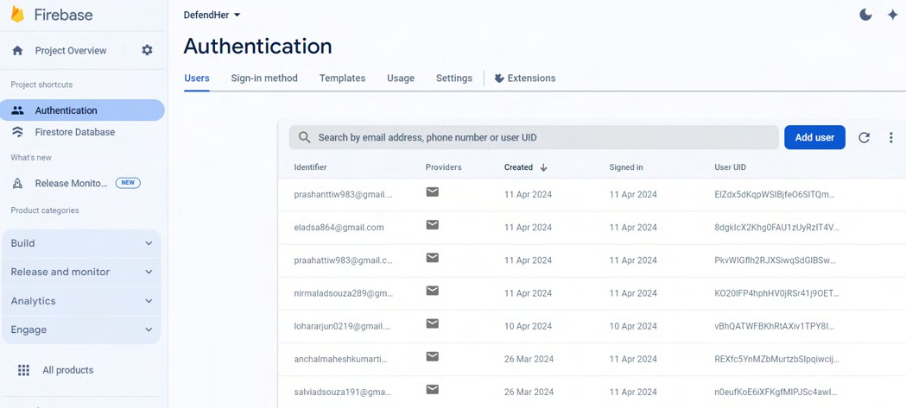

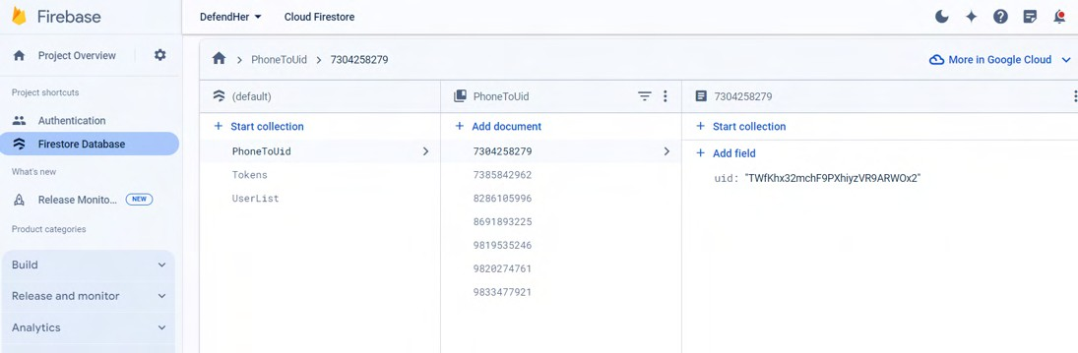

Figure 9.4: Database

- Home Page:
This screen represents the homepage which has an
- SOS button
- Emergency Contacts
- Helpline
- Safety Tips & Laws
- About

When the SOS Button is pressed it allows to play the siren, send SMS to emergency contacts and shake detection services.

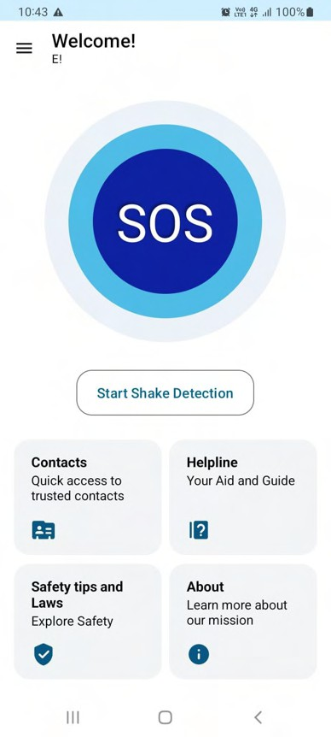

Figure 9.5: HomePage

- Emergency Contacts Page:

The contacts list allows users to store information about the people they can contact in case of emergency and when the press the SOS Button then a location will be sent to this number via SMS.

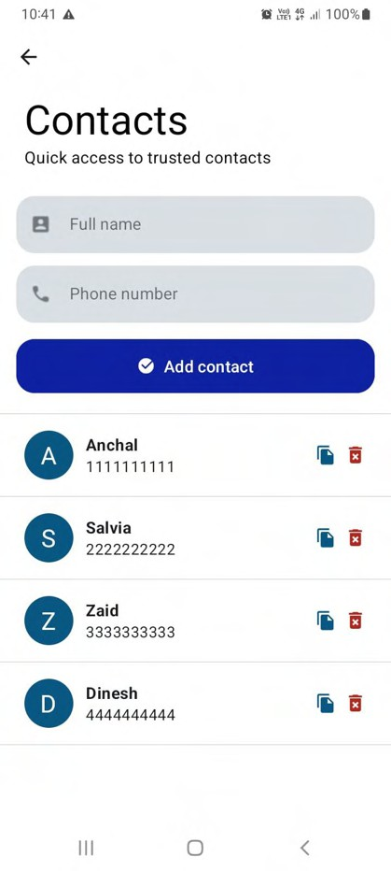

Figure 9.6: Emergency Contacts

- SMS Alert:

When user presses SOS Button, a notification will be sent to the contacts and location link will be shared.

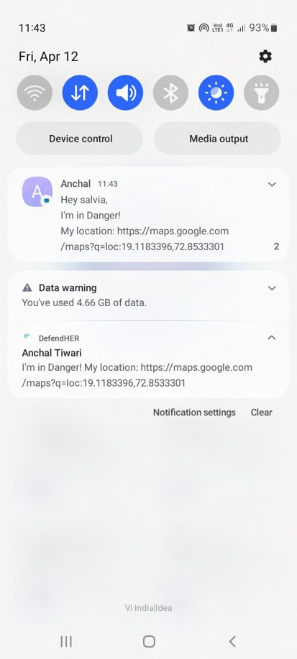
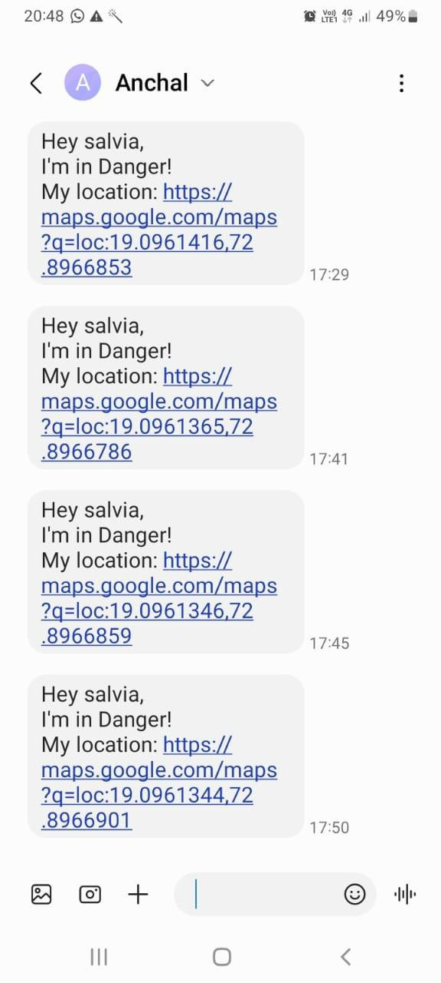

Figure 9.7 Alert Message

- Location:

This image represents the current location of the victim that is sent to the contacts that are present it the emergency contact list so that they can track the victim’s current location.

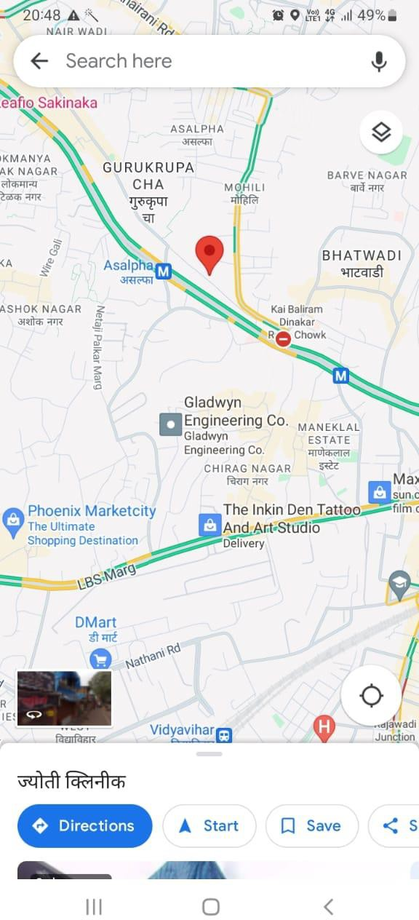

Figure 9.8: GPS Location

- Helpline Page:

This section includes all the helpline numbers that will help in case of emergency and the victim can contact them and get immediate help.

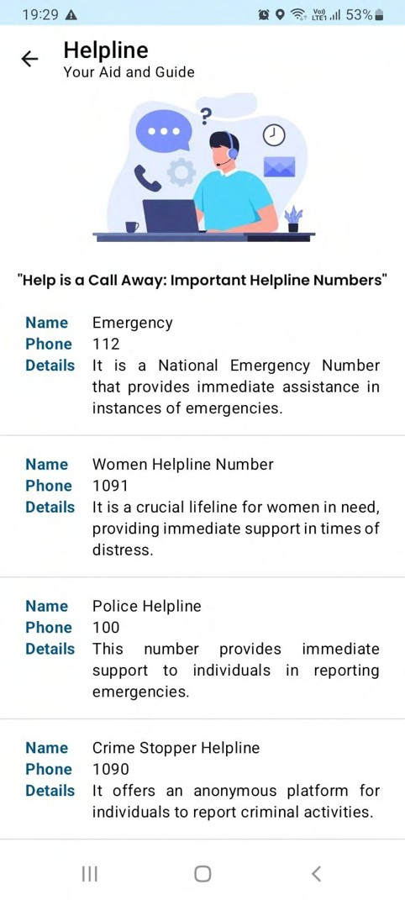

Figure 9.9: Helpline

- Self-defence Page:

This section includes defense tips that will help users to become aware and to increase self-confidence and how face an unsafe situation.
It also has a set of Laws which will make the users aware about their rights and powers.

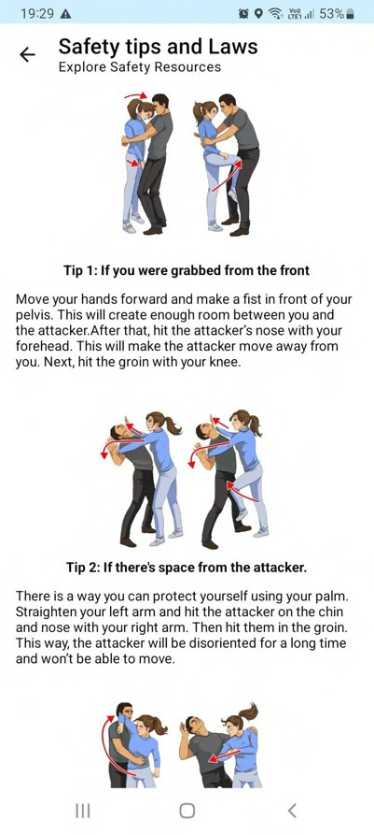
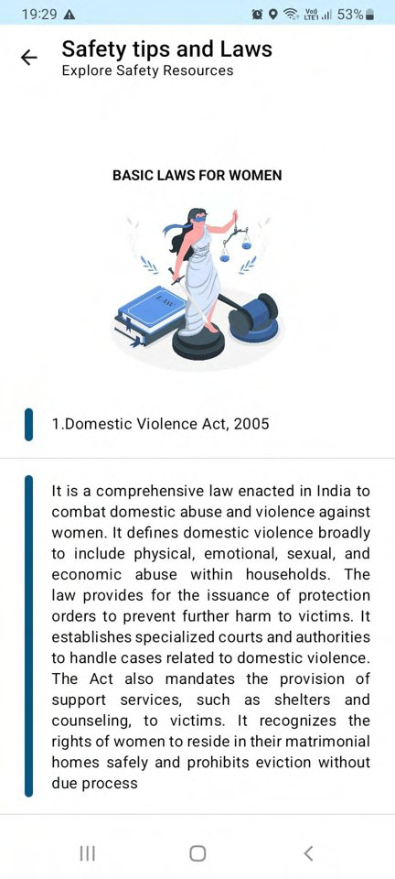

Figure 9.10: Tips & Laws

- Navigation Drawer:

This represents a Navigation Drawer which includes Profile, Settings & Logout function. Users can Edit their profile, Manage settings and Logout of the app.
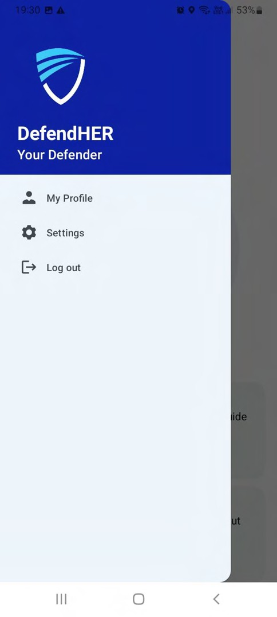

Figure 9.11: Navigation Drawer

- Profile Page:

In My Profile page, Users can view their profile i.e details and also Edit their Profile.

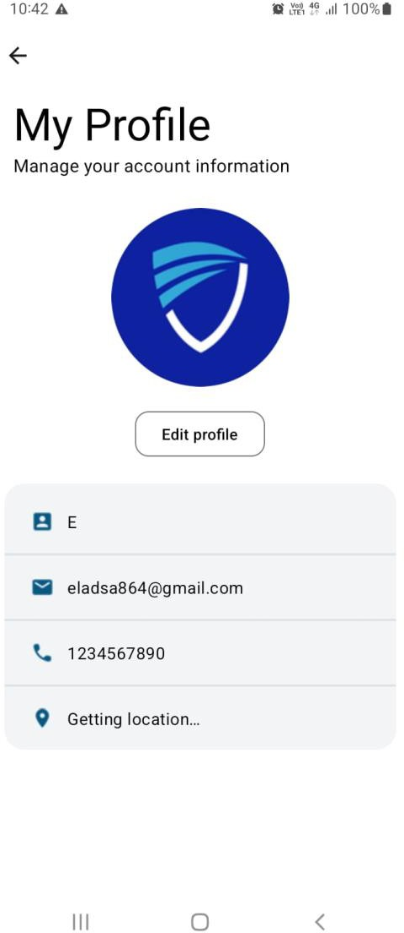
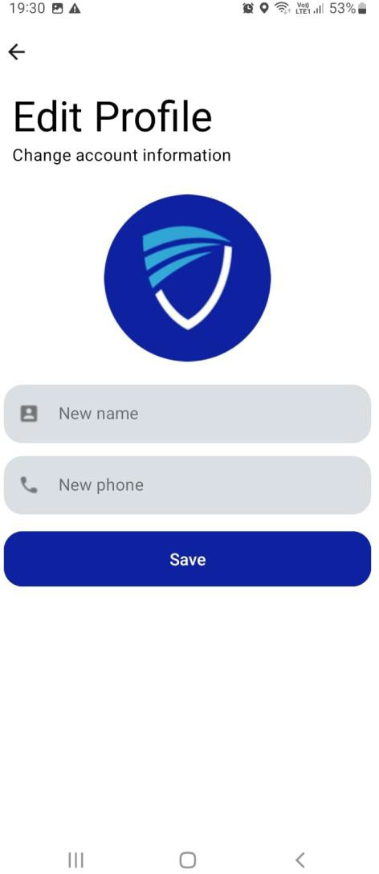

Figure 9.12: Profile

- Settings:

The Settings Page includes the following:

- Shake detection: This feature allows users to send an SOS by shaking their phone.
- Send SMS: This feature allows users to send an SOS message via SMS and notification.
- Play siren: This feature allows users to play a fake police siren at full volume in emergency mode.
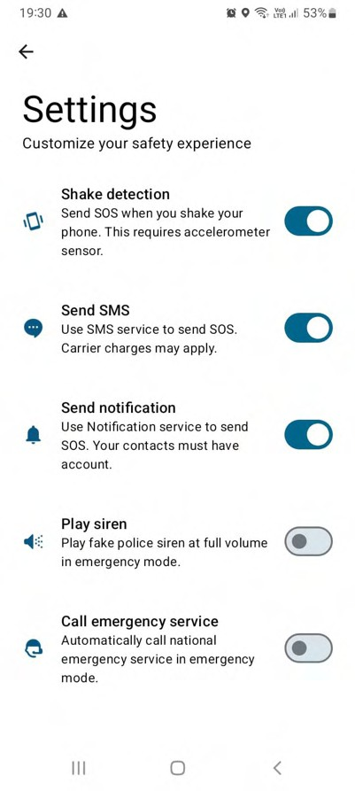
- Call emergency service: This feature allows users to automatically call national emergency services.
Figure 9.13: Settings

FUTURE PROSPECTS

Community Engagement Features:

  - Community Alert:

Permit users to report occurrences of suspicious activity or crimes they witness nearby. This can be completed anonymously and contribute to the development of an awareness network among users.

Safety forums:

Create a place for users to share safety tips, discuss concerns, and get support from other women. This can create a sense of community and empower users.

Volunteer Networks:

Enable users to make connections with volunteers who are prepared to provide them
with a listening ear, take them home at night, or accompany them to public locations. This can add a crucial element of security, particularly for people who don't feel comfortable venturing out by themselves.

Artificial Intelligence for Personalization and Safety:

  - Personal security systems:

Use AI to analyze user behavior, routines, and location data to identify potential risks and suggest personal security recommendations.

Smart Threat Detection:

Create AI algorithms that can scan the user’s surroundings using the phone’s camera and microphone to identify potential threats. This may include identifying weapons, suspicious characters, or aggressive language.

Predictive Safety Alerts:

AI is used to identify potential dangers for a user and provide warnings in advance. For instance, the app might notify a user to reveal their position or initiate a fictitious call if they happen to be strolling through a known crime hotspot at night.

Chatbot for Support and Guidance:

  - 24/7 Safety Assistant:

Implement a chatbot that users can contact at any time for safety tips, incident reports, or simply for emotional support. This can be especially helpful for users who are uncomfortable calling the emergency services or have no one to talk to.

Security Information Recovery:

Build a chatbot that can answer users’ questions about security features, defense mechanisms, or legal procedures after an attack. This makes it easier for users to access important information in real time.

10. LIMITATIONS

Dependence on Technology:

Women’s safety apps are valuable tools for improving personal safety, but their effectiveness depends on smartphone reliability and network connectivity where the user’s phone battery suddenly runs out or app performance can suffer as they have critical network constraints, any interruptions in network connectivity or equipment failures can severely hinder the application’s ability to provide timely alerts or calls for help. This reliance on technology highlights the importance of users focusing on network availability to maintain their devices in optimal conditions, especially in environments that are sensitive to signals that will interfere or have fewer interactions, making women’s safety measures more effective.

False Alarms:

Although women's safety apps are made to offer a prompt and efficient reaction during emergencies, false alarms can still happen from time to time. Accidental touches or misunderstanding app features might cause users to mistakenly trigger emergency alarms, which could cause needless panic and put a burden on emergency response resources. Additionally, a high amount of notifications that turn out to be non-urgent can cause authorities to get used to true emergencies due to the predominance of false alarms. This desensitization is dangerous because it could lead to insufficient or delayed reactions to actual emergencies, endangering the security of those who are most in need. The impact of false warnings should be reduced by women's safety applications having elements like confirmation.

Limited coverage:

Women’s safety apps may not work well in all environments, especially in areas with poor network connectivity or limited access to emergency services. In remote or rural areas, where infrastructure and telecommunications networks are underdeveloped, women’s safety systems may struggle to function effectively due to unreliable internet connectivity or lack of mobile phone access, therefore, This restriction poses significant challenges to individuals living in these areas, due to the availability of safety measures needed in an emergency Resources and availability may be unavailable Furthermore, where emergency services are scarce or are inaccessible, women’s safety services may not be able to provide timely support or communication with local authorities, leaving users vulnerable to long-term distress and uncertainty.

Response Time:

Women's safety apps are a useful tool for notifying emergency services or designated contacts in an emergency, but how well they work in emergencies depends on several variables, such as the user's location accuracy and the accessibility of emergency services. The possibility of getting a timely and well-coordinated response to alerts issued by women's safety apps may be higher in crowded urban regions with established emergency response systems than in rural or remote areas with limited or non-existent emergency services. Furthermore, users' overall response times may be impacted by emergency dispatch centers’ ability to manage incoming alerts and prioritize response efforts.

11. CONCLUSION

  - In conclusion, StoriesOfUs stands as a powerful tool in championing women's safety, offering a comprehensive suite of features designed to empower and protect. By seamlessly integrating real-time tracking, emergency alerts, and Self-defense Tips.

  - It is more than an app; it's a guardian, providing a sense of security in every pocket. As we navigate the digital landscape of safety, It remains committed to its mission of ensuring the well-being and confidence of every user.

  - StoriesOfUs—a steadfast companion in your journey toward a safer, more secure future. Let’s continue illuminating our way forward.

  - It is unwavering in its aim to protect everyone's safety in the face of ever changing safety risks. With constant support and effort, It illuminates our path forward as we continue to navigate towards a safer and more secure future. Together, let's maintain everyone's safety and sense of empowerment.

  - It is a change-catalyst, not just a safety app. It creates a cascading effect when women are provided with the means and instruments necessary to maintain their safety. Broader discussions about safety and prevention might be sparked by heightened awareness and a feeling of community. As more women feel comfortable going out into the world, the status quo is challenged and a future where everyone may feel confident and free is paved

  - It is an appeal to establish a society in which everyone has the right to safety rather than seeing it as a privilege. Together, let's pave the way for a more promising and secure future for everybody.

10. REFERENCES

- AbhiRaksha: Advanced Women Safety App. Behance. https://www.behance.net/gallery/93648247/AbhiRaksha-Advanced-Women-Safety-App

- Crime Against Women in India: A Look at NCRB Report 2023. NewsClick. https://www.newsclick.in/crime-against-women-india-4-ncrb-report-2023

- Srinivas, K., Gothane, S., Krithika, C. S., Anshika, & Susmitha, T. (2024). Android App for Women Safety. International Journal of Scientific Research in Computer Science, Engineering and Information Technology, 24(5), 378.
https://doi.org/10.32628/CSEIT1217368

- diagrams.net. https://app.diagrams.net/

- Google Gemini. https://gemini.google.com/app

- Blackbox.ai. Expert Android Chat. https://www.blackbox.ai/chat/expert-android\

- FreePik: Images, Illustrations, Icons: https://www.freepik.com/

- Wikipedia (Violence against Women in India): https://en.wikipedia.org/wiki/Violence_against_women_in_India

- Bright Side (Self-defence Techniques for Women Article):
Bright Side. 7 Self-Defense Techniques for Women Recommended by a https://brightside.me/articles/7-self-defense-techniques-for-women-recommended-by-a-professional-441310/

- YouTube Video Reference:
URL: https://www.youtube.com/watch?v=NkE4sxeAfFE&t=170s

- National Commission for Women (List of Laws Related to Women): http://ncw.nic.in/important-links/List-of-Laws-Related-to-Women

- National Crime Records Bureau: https://ncrb.gov.in/

